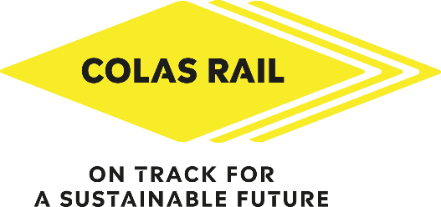

12th Annual Football Tournament
Registration Form
Event Date: Wednesday 11th September 2024
Deadline to Apply: 29th July 2024

Team Name:

Captain’s Full Name:

Phone number: E-mail address:

Player | Surname | Forename | E-mail Address | Size of T-shirt*
1

2

3

4

5

6 Sub

7 Sub
8 Sub

Size of clothing Chest Size  S 34/36  M 38/40  L 42/44  XL 46/48  XXL 50/52 | *The sizing of the kits is approximate; we recommend ordering the next size up (i.e., if you're a medium, order a large).

Send your registration form by e-mail to marketing@colasrail.com no later than the
29th of July 2024 in order to get names on shirts!

Spaces are limited so to avoid disappointment build your team and sign up now!

