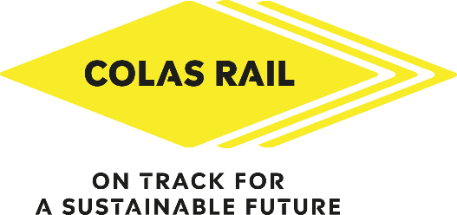

11th Annual Football Tournament
Registration Form
Event Date: Wednesday 13th September 2023

To enter simply complete the form below:

Team Name:

Captain’s Full Name:

Phone number: E-mail address:

Player | Surname | Forename | E-mail Address | Size of T-shirt*
1

2

3

4

5

6 Sub

7 Sub
8 Sub

*The sizing of the kits is approximate; we recommend ordering the next size up (i.e., if you're a medium, order a large).
Size of clothing Chest Size
S 34/36
M 38/40
L 42/44
XL 46/48
XXL 50/52
Send your registration form by e-mail to marketing@colasrail.com no later than the 2^{nd of} August 2023 in order to get names on shirts!
Spaces are limited so to avoid disappointment build your team and sign up now!

