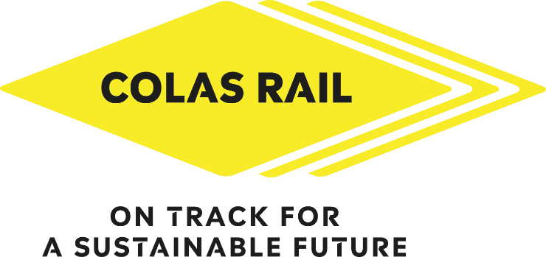

Colas Rail 11th Anniversary Football Tournament
Frequently Asked Questions

1) Who can participate in the football tournament?
The Colas Rail football tournament is open to all full-time employees of Colas Rail Limited as well as members of the various alliances.
2) When and where is the football tournament?
When: Wednesday 13th September 2023
Where: Goals Birmingham- Perry Barr, Tameside Park, Aldridge Road, Birmingham, B42 2UB
Time: 11:00am – 5:30pm
3) How do I enter?
Entrants must have permission to participate from their line manager before applying. To enter,
simply complete the registration form and send to marketing@colasrail.com by Wednesday 2nd August 2023
4) Is the football tournament a paid day?
Yes. Colas Rail employees will be paid by Colas Rail.
Other information:
• The maximum number of players allowed per team is 5 with 2 substitutes
• Players are not allowed to transfer from one team to another team during the competition
• Single players can register; we will do our best to build a team from single players
• All players will receive a Colas Rail football kit
• The winning team will be announced on the day
• Players must bring their own socks, shin pads and suitable footwear

May the best team win!

