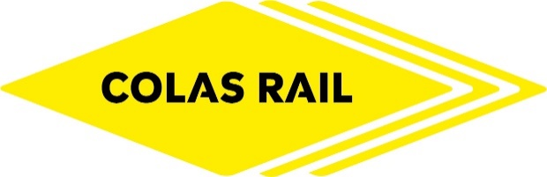

**Colas Rail Football Tournament**

**Registration Form**

**Event Date: Wednesday 6th October 2021**

To enter simply complete the form below:

Team Name:

Captain’s Full Name:

Phone number: E-mail address:

|  |  |  |  |  |
| --- | --- | --- | --- | --- |
| Player | Surname | Forename | E-mail Address | Size of T-shirt |
| 1 |  |  |  |  |
| 2 |  |  |  |  |
| 3 |  |  |  |  |
| 4 |  |  |  |  |
| 5 |  |  |  |  |
| 6 Sub |  |  |  |  |
| 7 Sub |  |  |  |  |

Size of clothing Chest Size

S 34/36

M 38/40

L 42/44

XL 46/48

XXL 50/52

Send your registration form by e-mail to [marketing@colasrail.com](mailto:marketing@colasrail.com) no later than the 8th September 2021

***Spaces are limited so to avoid disappointment build your team and sign up now!***